Dissecting the Digital Landscape: A Comprehensive Analysis of Social Media

Dissecting the Digital Landscape: A Comprehensive Analysis of Social Media" is a research article or paper that provides a detailed and in-depth analysis of various social media platforms, including Facebook, Twitter, Instagram, YouTube, and LinkedIn. The analysis

covers a wide range of topics related to social media, such as the history and evolution of social media, the demographics of social media users, the impact of social media on

communication and society, the role of social media in politics and activism, and the challenges and opportunities of social media for businesses and organizations.

The paper draws on a wide range of research studies, surveys, and data sources to provide a comprehensive overview of the digital landscape and its implications for individuals, organizations, and society as a whole. Overall, the paper aims to provide a comprehensive

and up-to-date understanding of the complex and dynamic world of social media(twitter as an example), and to inform future research, policy, and practice in this rapidly evolving field.

**Technical Architecture:**

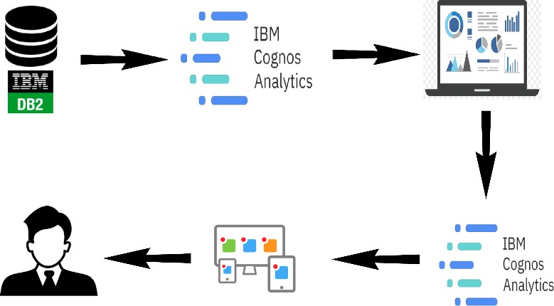

## Project Flow

To accomplish this, we have to complete all the activities listed below,

Define Problem / Problem Understanding

* Specify the business problem
* Business requirements
* Literature Survey
* Social or Business Impact.
* Data Collection & Extraction from Database
  + Collect the dataset,
  + Connect IBM DB2 with IBM cognos
* Data Preparation
  + Prepare the Data for Visualization
* Data Visualizations
  + No of Unique Visualizations
* Dashboard
  + Responsive and Design of Dashboard
* Story
  + No of Scenes of Story
* Report
  + Creating a report
* Performance Testing
  + Amount of Data Rendered to DB ‘
  + Utilization of Data Filters
  + No of Calculation Fields
  + No of Visualizations/ Graphs
* Web Integration
  + Dashboard and Story embed with UI With Flask
* Project Demonstration & Documentation
  + Record explanation Video for project end to end solution
  + Project Documentation-Step by step project development procedure

# Milestone 1: Define Problem / Problem Understanding

## Activity 1: Specify the business problem

Refer Project Description

## Activity 2: Business requirements

The business requirements for this project would likely include

Data collection: The first requirement is to collect data from Twitter that is relevant to the number of tweets,retweets,likes and shares.

Data cleaning and preparation: The collected data must be cleaned and processed to ensure it is suitable for analysis. This may involve removing irrelevant information, correcting inconsistencies and missing values, and transforming the data into a format that is compatible with the analysis tools.

Data analysis: The data must be analysed to uncover meaningful insights.This could involve using techniques such as descriptive statistics, regression

analysis, and data visualization to gain a deeper understanding of the data.

Report creation: The insights and findings from the data analysis must be presented in a comprehensive report that includes visualizations and data tables. The report must be well organized and easy to understand, with

clear and concise explanations of the results.

## Activity 3: Literature Survey (Student Will Write)

A literature survey for a project titled "Tweet, Tweet, Retweet: Conversational Aspects of Retweeting on Twitter” , Social media has enabled conversations to occur asynchronously and beyond geographic constraints, but they are still typically bounded by a reasonably well defined group of participants in some sort of shared social context. Network-driven genres (e.g., social network sites, microblogging) complicate this because people follow the conversations in the context of individuals, not topical threads. Yet, conversations still

emerge between dyads and among groups.

Overall, the literature survey would provide a comprehensive overview of the current state of knowledge in the field of Social media and would provide a

foundation for the analysis and report creation aspects of the project.

## Activity 4: Social or Business Impact.

**Social Impact:** The findings from this project could help people have a better understanding on Social media.

**Business Model/Impact**: Social media provides businesses with a platform to reach a wider audience and increase brand awareness through targeted

advertising and content marketing.

# Milestone 2: Data Collection & Extraction from Database

Data collection is the process of gathering and measuring information on variables of interest, in an established systematic fashion that enables one to answer stated research questions, test hypotheses, and evaluate outcomes and generate insights from the data.

## Activity 1: Collect the dataset

Please use the link to download the dataset:

[**https://data.world/markbradbourne/rwfd-real-world-fake-data/workspace/file?filename=Social**](https://data.world/markbradbourne/rwfd-real-world-fake-data/workspace/file?filename=SocialMedia.csv)

[**M edia.csv**](https://data.world/markbradbourne/rwfd-real-world-fake-data/workspace/file?filename=SocialMedia.csv)

## Activity 1.1: Understand the data

Check the below link out to understand the dataset in detail:

[**https://data.world/markbradbourne/rwfd-real-world-fake-data/workspace/file?filename=SocialM**](https://data.world/markbradbourne/rwfd-real-world-fake-data/workspace/file?filename=SocialMedia.csv)[**edia.csv**](https://data.world/markbradbourne/rwfd-real-world-fake-data/workspace/file?filename=SocialMedia.csv)

## Activity 2: Connect IBM DB2 with IBM Cognos

# Milestone 3: Data Preparation

## Activity 1: Prepare the Data for Visualization

Preparing the data for visualization involves cleaning the data to remove irrelevant or missing data, transforming the data into a format that can be easily visualized, exploring the data to identify patterns and trends, filtering the data to focus on specific subsets of data, preparing the data for visualization software, and ensuring the data is accurate and complete. This process helps to make the data easily understandable and ready for creating visualizations to gain insights into the performance and efficiency.

* + - **Activity 1.1** : **Preparing a Data Module**:

# Milestone 4: Data Visualization

Data visualization is the process of creating graphical representations of data in order to help people understand and explore the information. The goal of data visualization is to make

complex data sets are more accessible, intuitive, and easier to interpret. By using visual elements such as charts, graphs, and maps, data visualizations can help people quickly identify patterns, trends, and outliers in the data.

## Activity 1: No of Unique Visualizations

The number of unique visualizations that can be created with a given dataset. Some common types of visualizations that can be used to analyse the Twitter data include bar charts, line charts, heat maps, scatter plots, pie charts,Maps etc. These visualizations can be used to compare performance, track changes over time, show distribution, and relationships between variables.

**Activity 1.1: URL clicks by retweets**

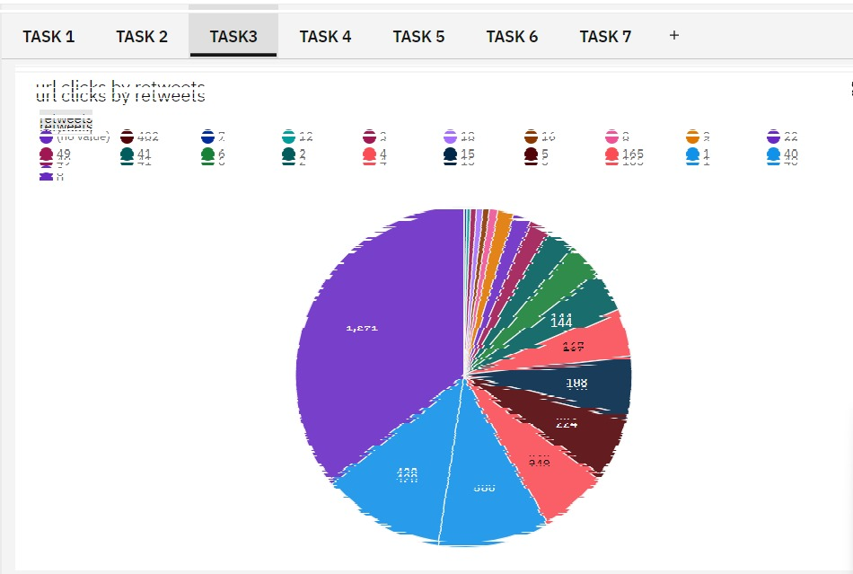

**Activity 1.2: Data of media view, media engagements**

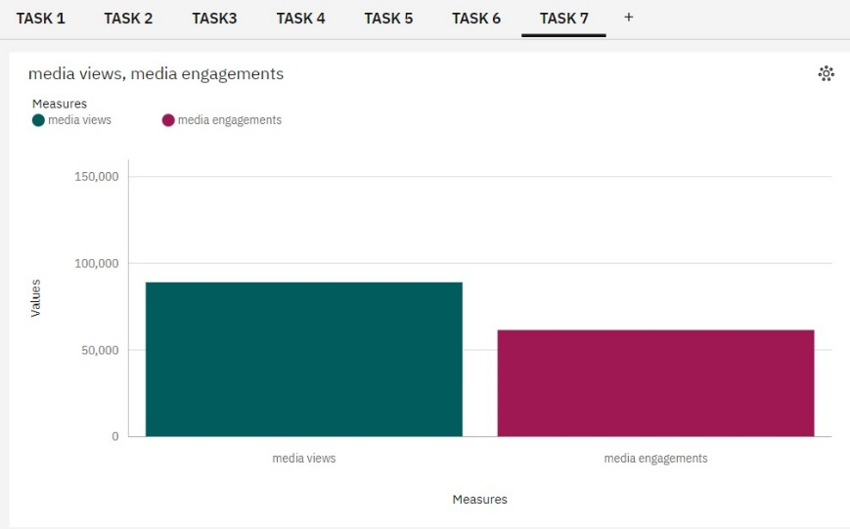

**Activity 1.3: retweets, email tweet and replies**

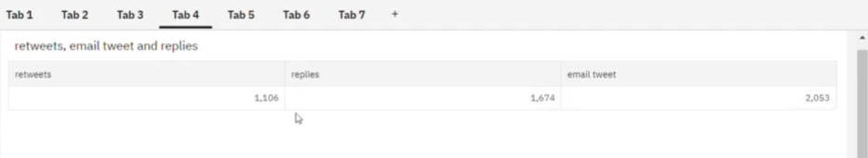

**Activity 1.4: Impressions by retweets**

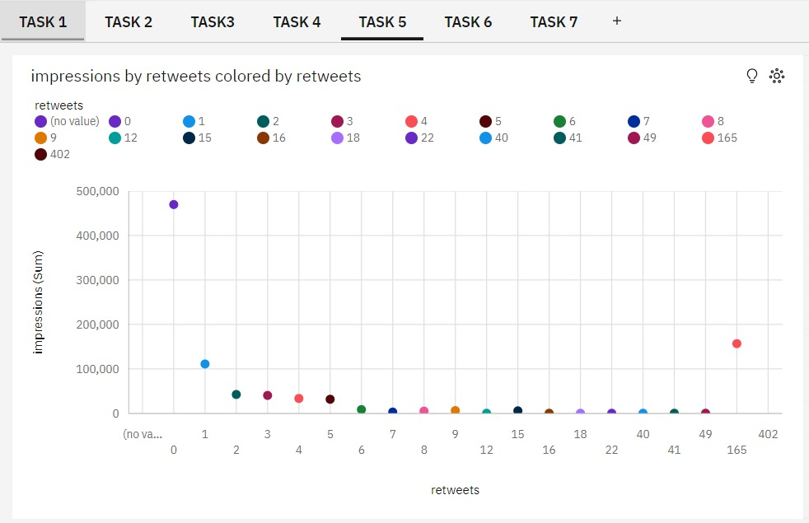

**Activity 1.5: Engagements by retweet in year**

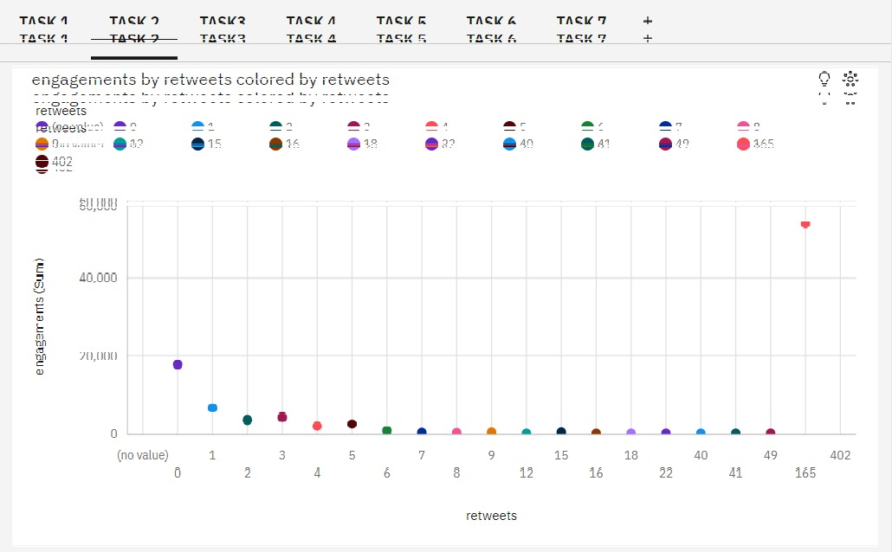

**Activity 1.6: Describe detailed expands through hashtag clicks** 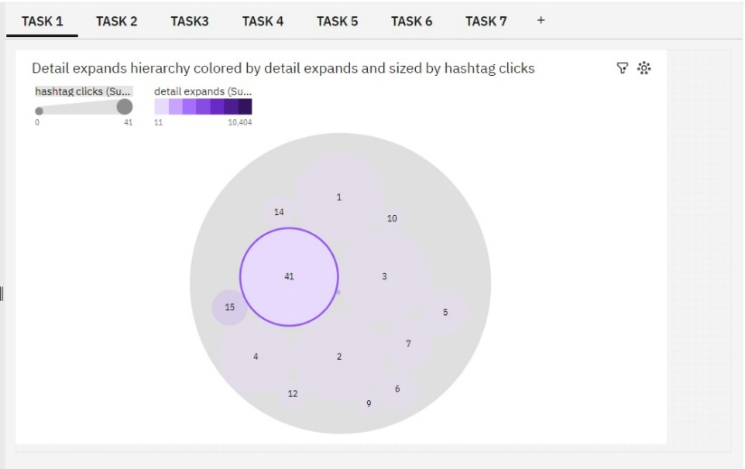

**Activity 1.7: impression by retweets colored by impressions**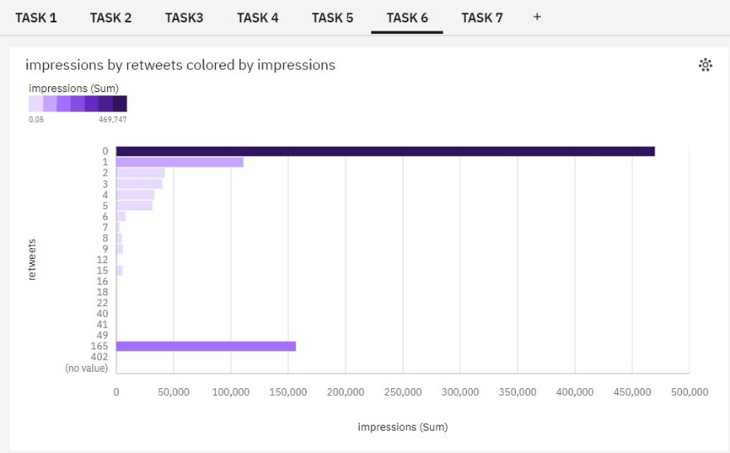

# Milestone 5: Dashboard

A dashboard is a graphical user interface (GUI) that displays information and data in an organized, easy-to-read format. Dashboards are often used to provide real-time monitoring and analysis of data, and are typically designed for a specific purpose or use case.

Dashboards can be used in a variety of settings, such as business, finance, manufacturing, healthcare, and many other industries. They can be used to track key performance indicators (KPIs), monitor performance metrics, and display data in the form of charts, graphs, and tables.

## Activity :1- Responsive and Design of Dashboard

The responsiveness and design of a dashboard for analyzing the factors important for Dissecting the Digital Landscape: A Comprehensive Analysis of social media analyzes various engagement metrics such as likes,

comments,

shares, and retweets to understand the level of engagement on different social media platforms. It analyzes social media trends and patterns to understand the changing preferences and interests of users.

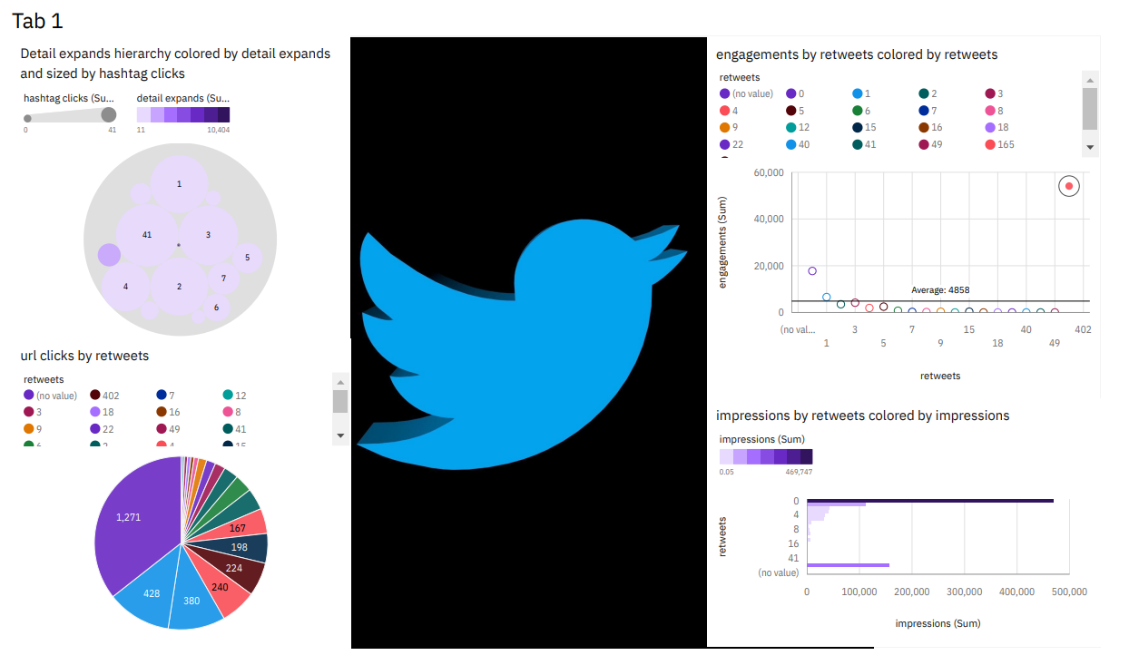

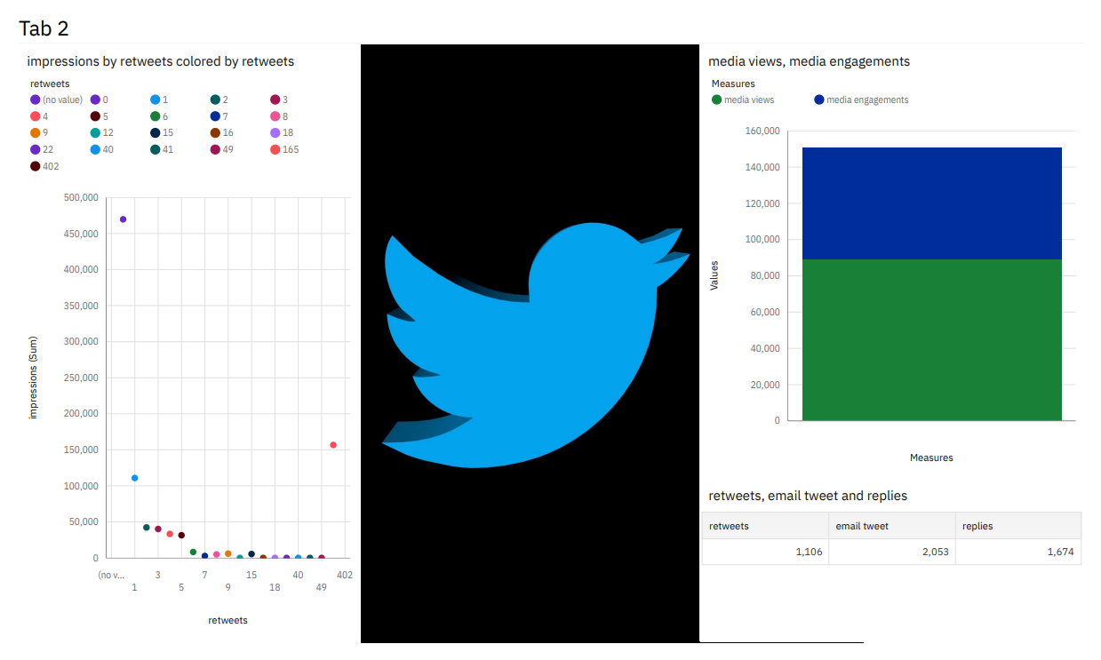

**Milestone 6: Story**

A data story is a way of presenting data and analysis in a narrative format, with the goal of making the information more engaging and easier to understand. A data story typically includes a clear introduction that sets the stage and explains the context for the data, a body that presents the data and analysis in a logical and systematic way, and a conclusion that summarizes the key findings and highlights their implications. Data stories can be told using a variety of mediums, such as reports, presentations, interactive visualizations, and videos.

## Activity:1- No of Scenes of Story

The number of scenes in a storyboard for a data visualization analysis of the factors affecting the insights of twitter , will depend on the complexity of the analysis and the specific insights that are trying to be conveyed. A storyboard is a visual representation of the data analysis process and it breaks down the analysis into a series of steps or scenes.

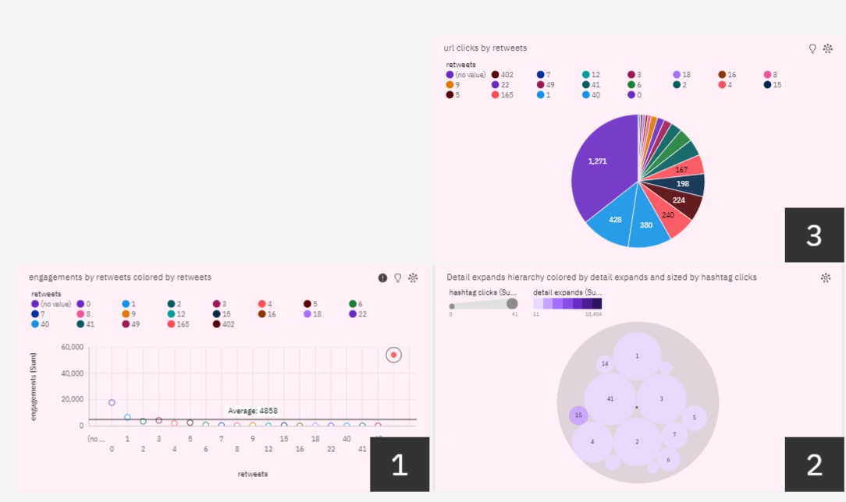

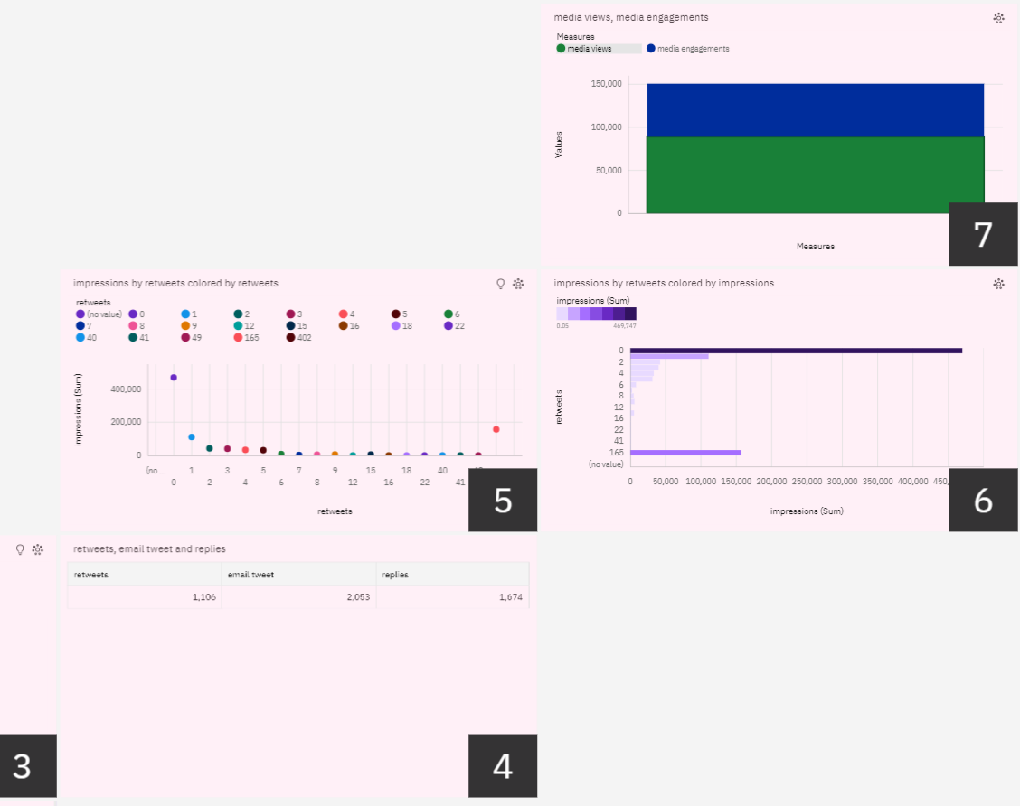

# Milestone 7: Report

A report is a document that presents information in a specific format and layout, usually based on data from a database or other data source. A report in IBM Cognos can contain various elements, such as tables, charts, graphs, and images, as well as text and data elements, and it is designed to be used by business users to help them better understand their data and make informed decisions. There are several different types of reports available in IBM Cognos, including list reports, crosstab reports, chart reports, and report studio reports, among others. The type of report that you choose will depend on the specific needs and requirements of your organization, as well as the data that you need to present.

## Activity 1 : Creating a report

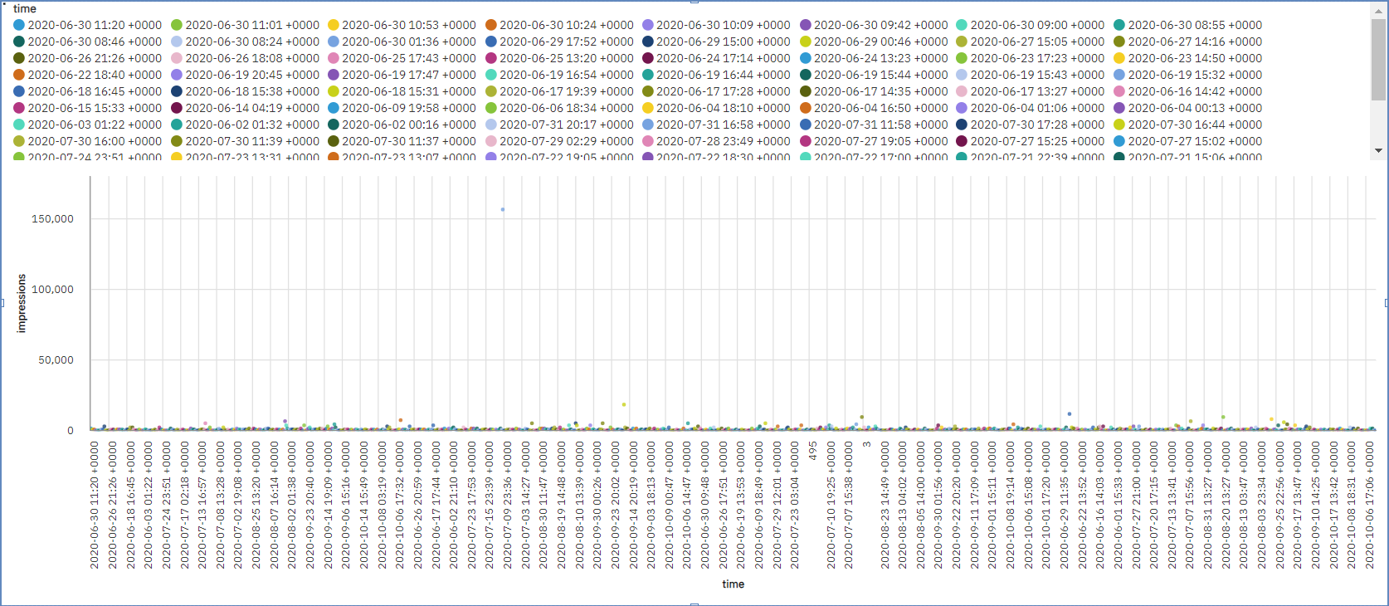

# Milestone 8: Performance Testing

## Activity 1: Amount of Data Rendered to DB2

* The amount of data that is rendered to a database depends on the size of the dataset and the capacity of the database to store and retrieve data.

## Activity 2: Utilization of Data Filters

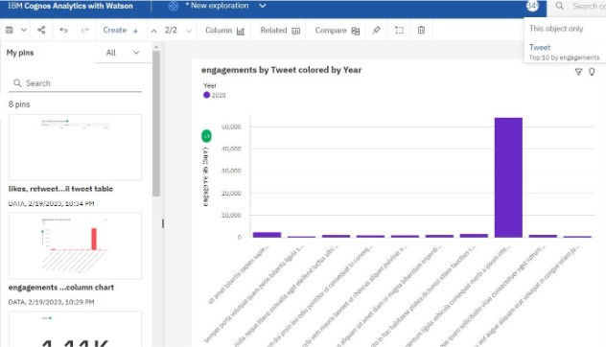

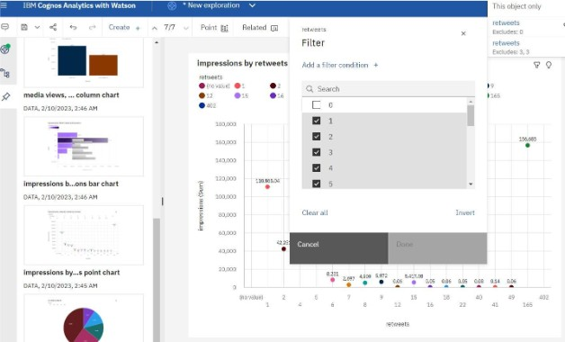

**Activity 3: No of Calculation Fields**

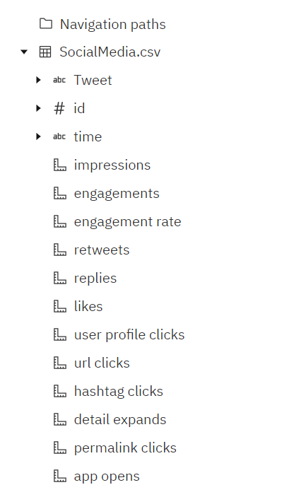

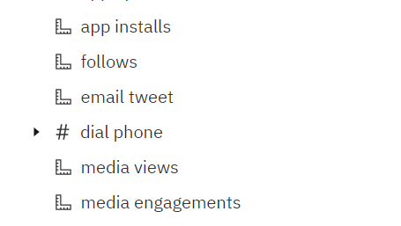

# Milestone 9: Web integration

Publishing helps us to track and monitor key performance metrics, to communicate results and progress. help a publisher stay informed, make better decisions, and communicate their performance to others.

**Integrating dashboard/reports/stories to web**

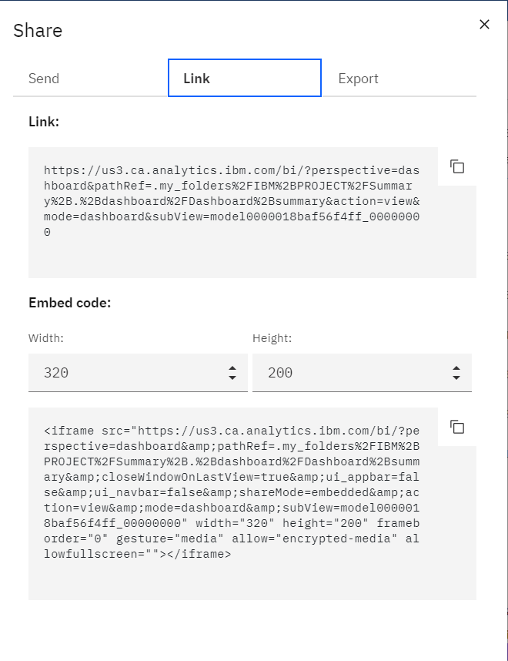

**Note: You can also change the width and height of the dashboard/story/report as you like.**

## Activity 1: Dashboard and Story embed with UI With Flask

**Explanation video**

**link: (All the explanations are in one video)** [**https://drive.google.com/file/d/1GZhrzvRToHZY6d7oQAhcpUoNy0GIcr_L/view?usp=sharing**](https://drive.google.com/file/d/1GZhrzvRToHZY6d7oQAhcpUoNy0GIcr_L/view?usp=sharing)

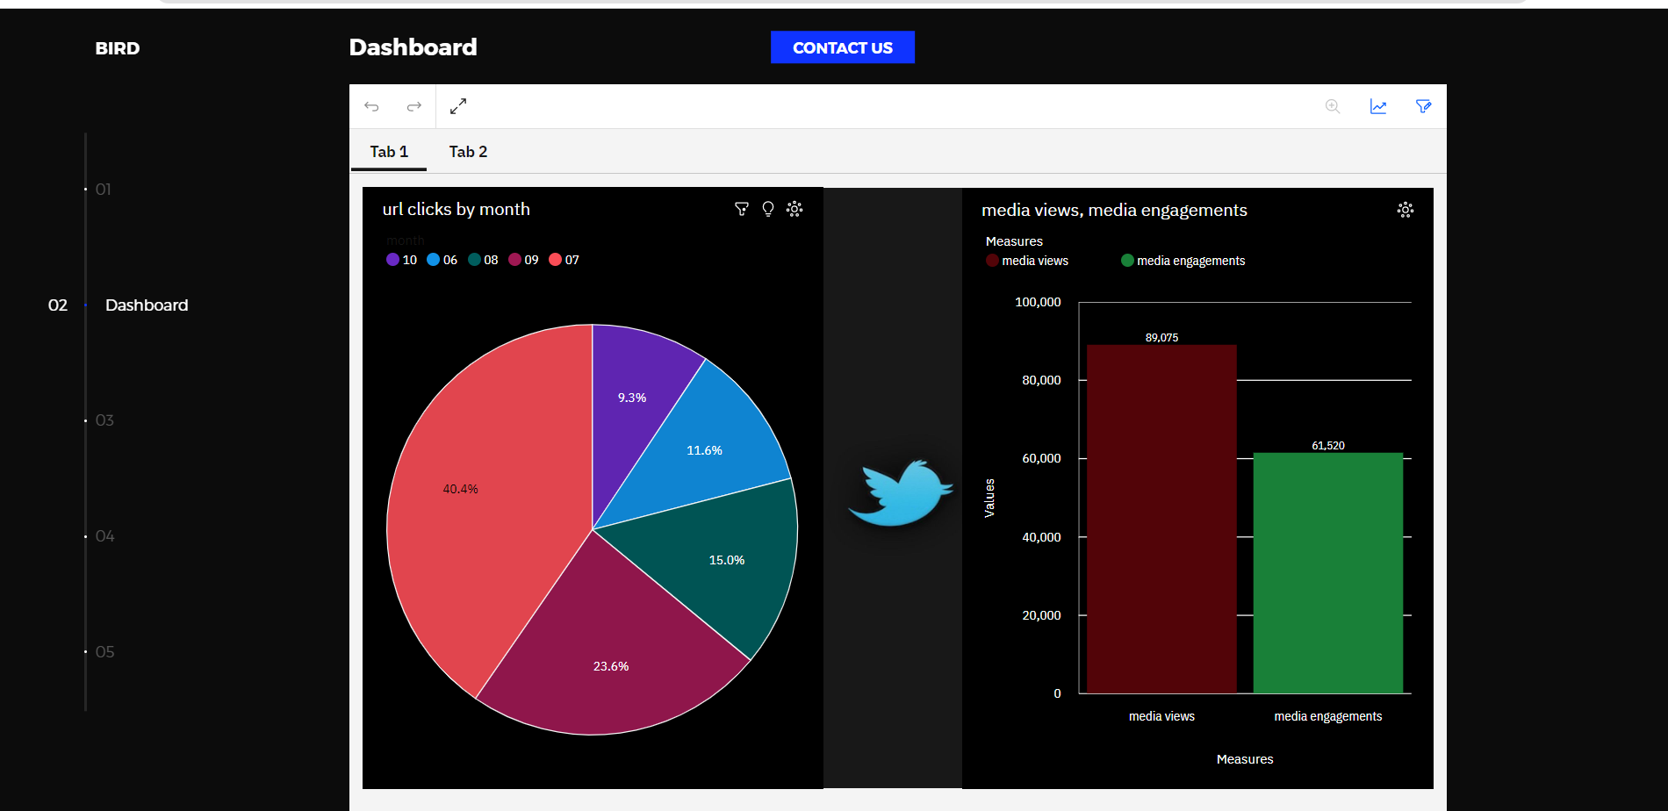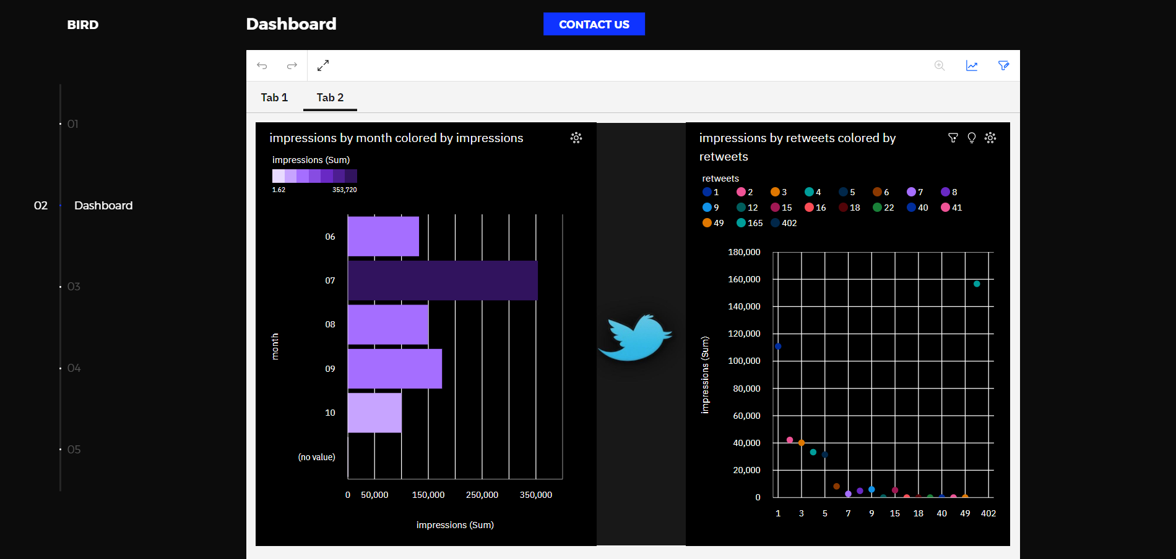

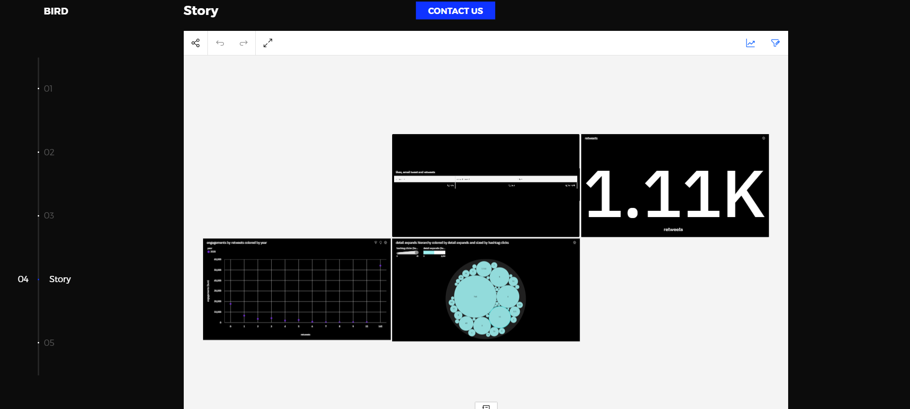

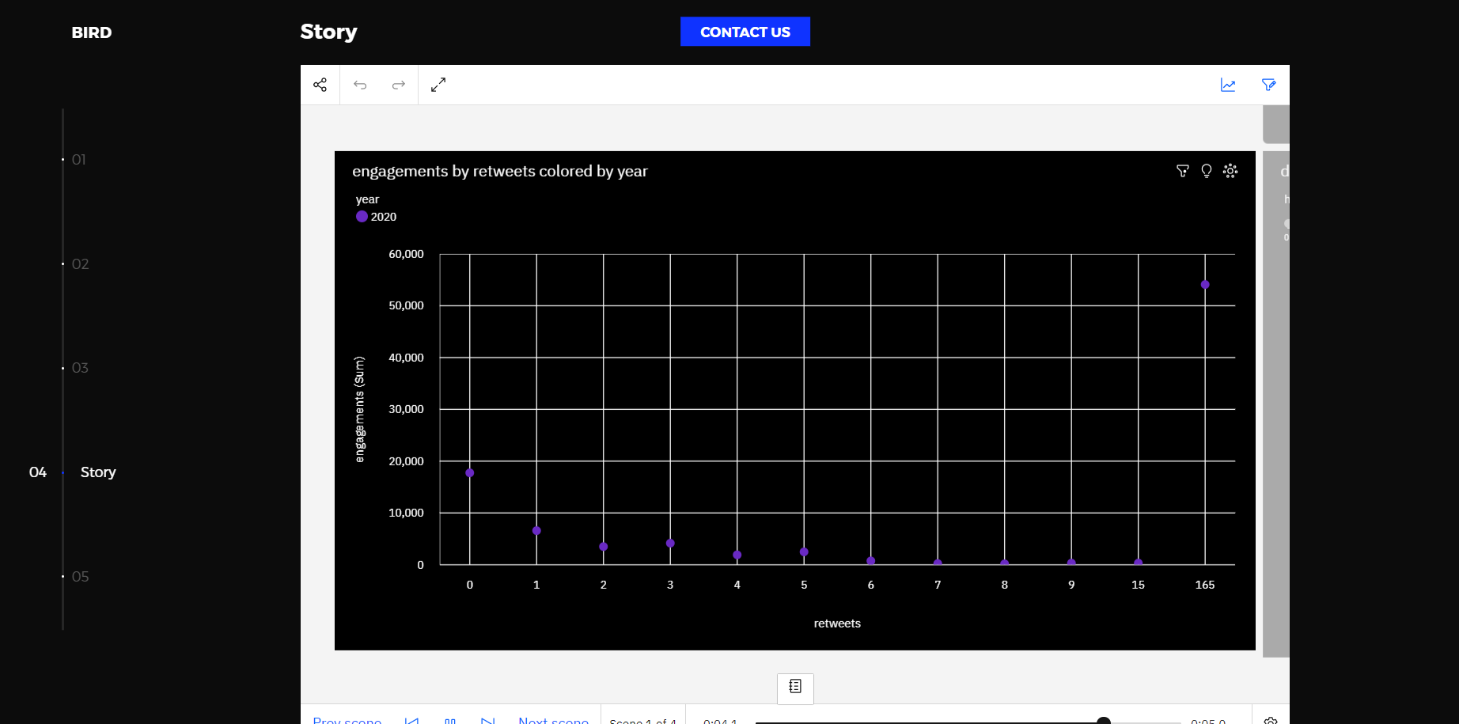

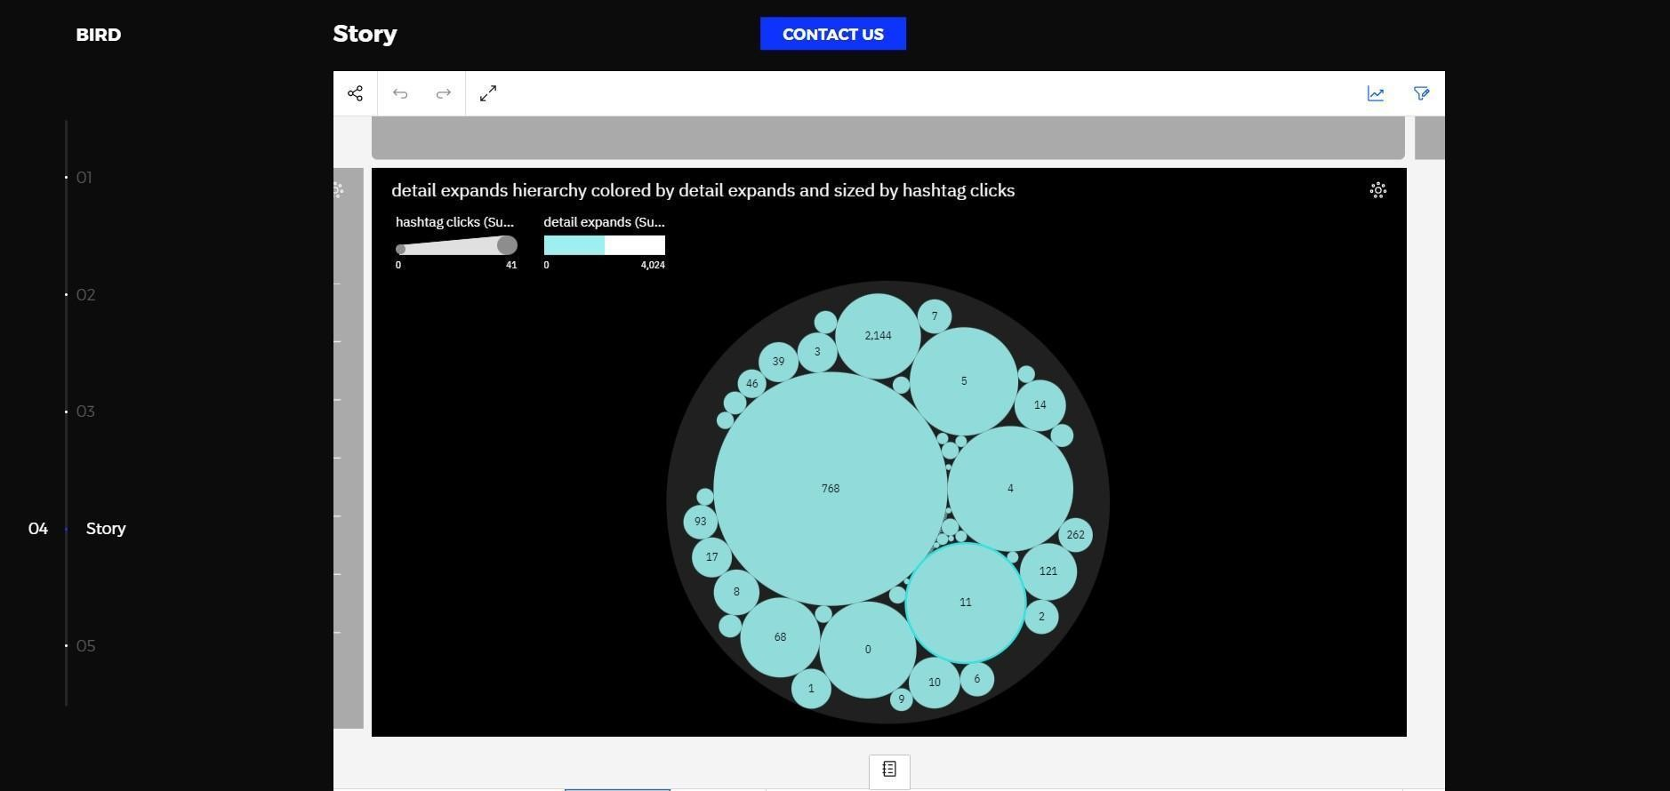

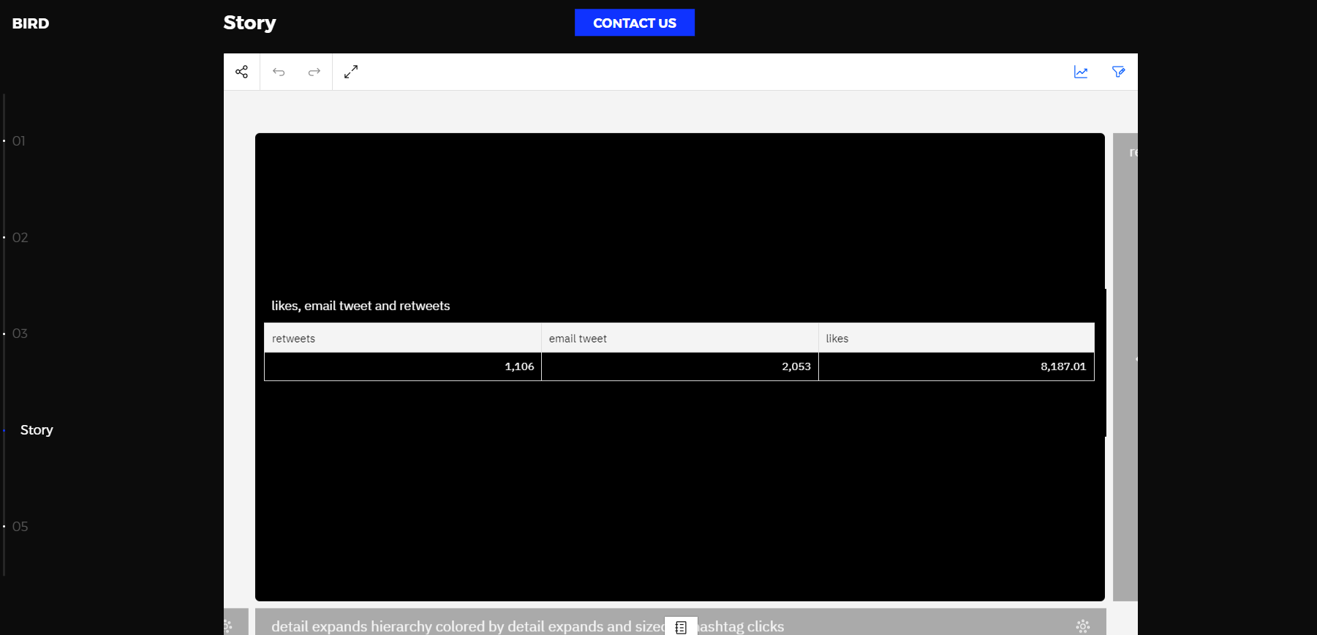

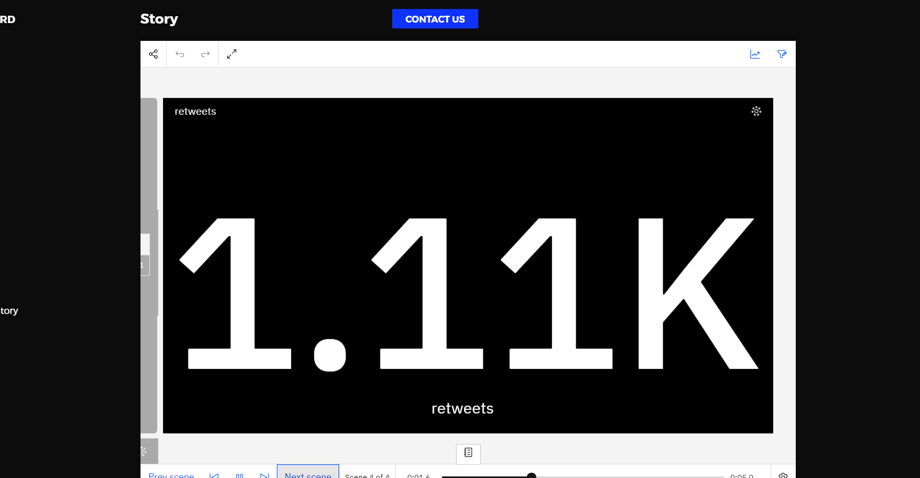

**Milestone 10: Project Demonstration & Documentation**

**Explanation video link:** [**https://drive.google.com/file/d/1GZhrzvRToHZY6d7oQAhcpUoNy0GIcr_L/view?usp=sharing**](https://drive.google.com/file/d/1GZhrzvRToHZY6d7oQAhcpUoNy0GIcr_L/view?usp=sharing)